

|  |  |  |  |  |  |  |  |  |
| --- | --- | --- | --- | --- | --- | --- | --- | --- |
|  | | | | | | | | |
|  | | Lab 01 | Applying Encryption and Hashing Algorithms for Secure Communications | | | | |  | |
|  |  | | | | | | |  |
|  | | | |  |  | | | |
|  | | | | Cesar Munguia |  | | | |
|  | | | | 09/10/2023—IS-3423-003—Darniet Jennings |  | | | |
|  | | |  | | |  | | |



|  |  |  |  |  |  |  |  |  |
| --- | --- | --- | --- | --- | --- | --- | --- | --- |
|  |  | | |  |  | | |  |
|  | Introduction | | | | | | |  |
|  |  | | |  |  | | |  |
|  |  | |  | | |  | |  |
|  |  |  | CIA (confidentiality, integrity, and authentication) is a major component in this lab that is emphasized. I will be applying cryptographic techniques to achieve this. I will be creating an MD5 checksum, a SHA-1 hash, an encryption key, and finally use key pairs to send messages between two machines. | | |  |  |  |
|  | | | | |
|  |  |  |  |
|  |  |



# Section 1: Hands on Demonstration

### Part 1: Create a Text File on Linux

Description: Here I started a remote connection with the TargetLinux01 machine. Whenever I got in, I created a new file by going to Applications > Accessories > gedit Text Editor. I typed “This is an example.” and saved as Example.txt

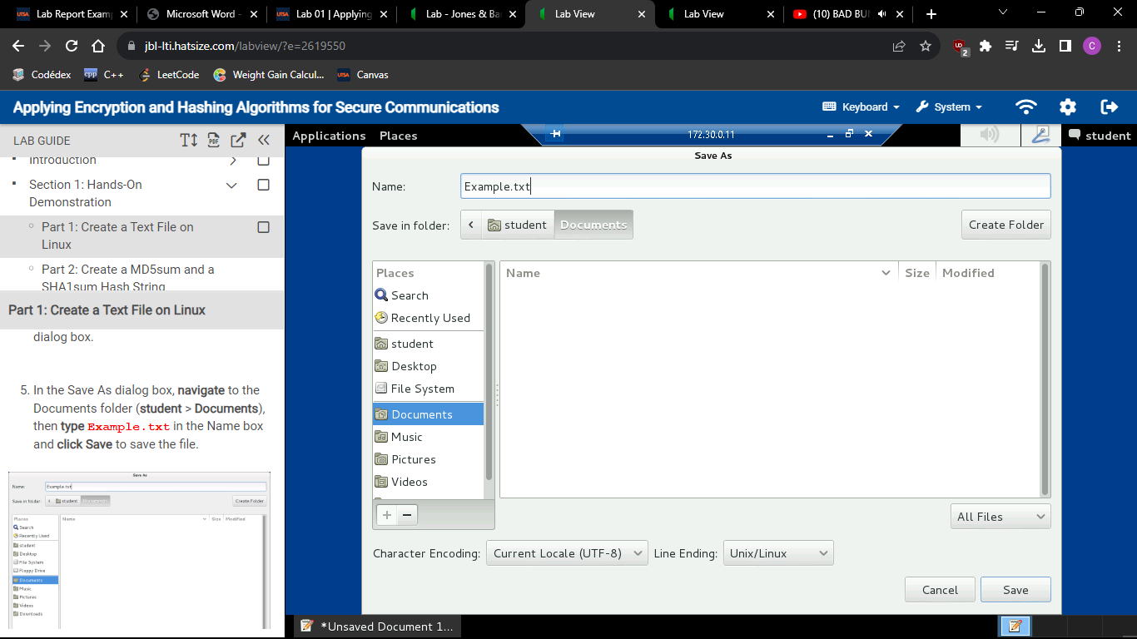

### Part 2: Create a MD5sum and a SHA1 Hash String

Description: I made two extra files with the Example.txt that I’ve previously created. One file contains the hash value for an MD5 value and the other contains the hash value for an SHA1 value. I cat-ed the files to double check their value and even used the -c option to check for its integrity. They both came out as “OK”. I showed this chronologically in the screenshots that are below.

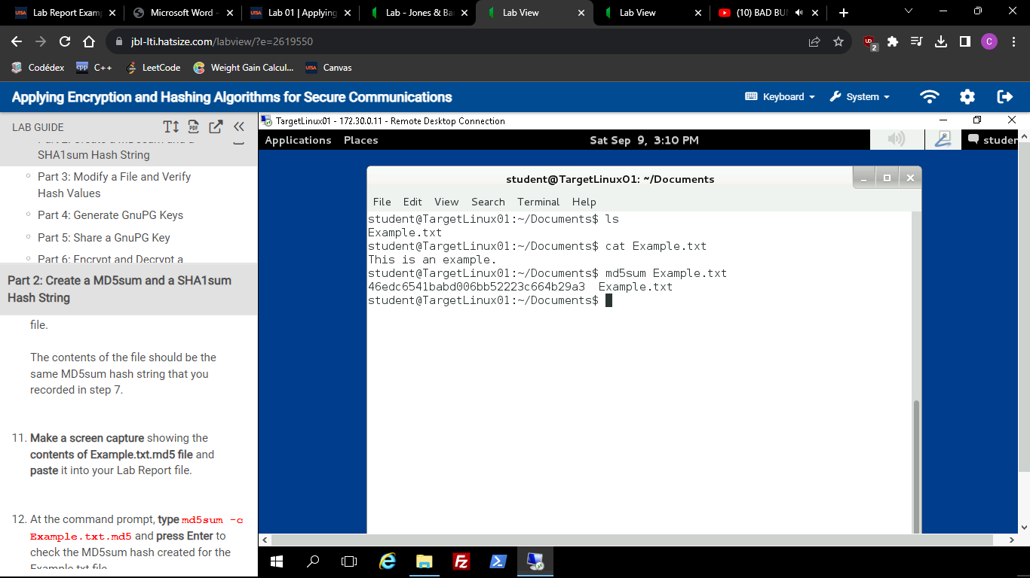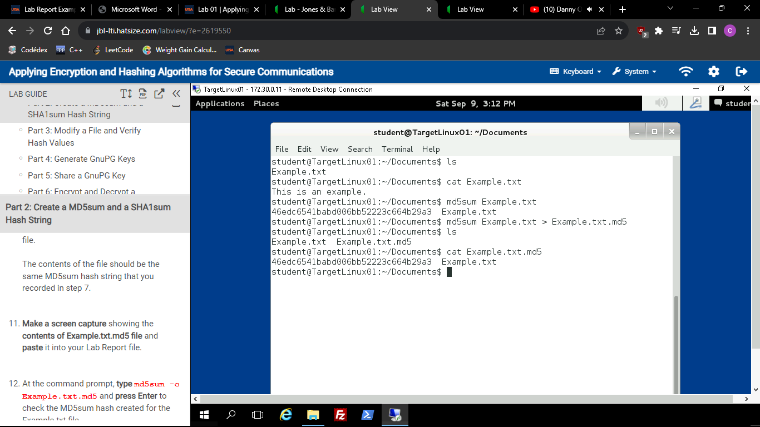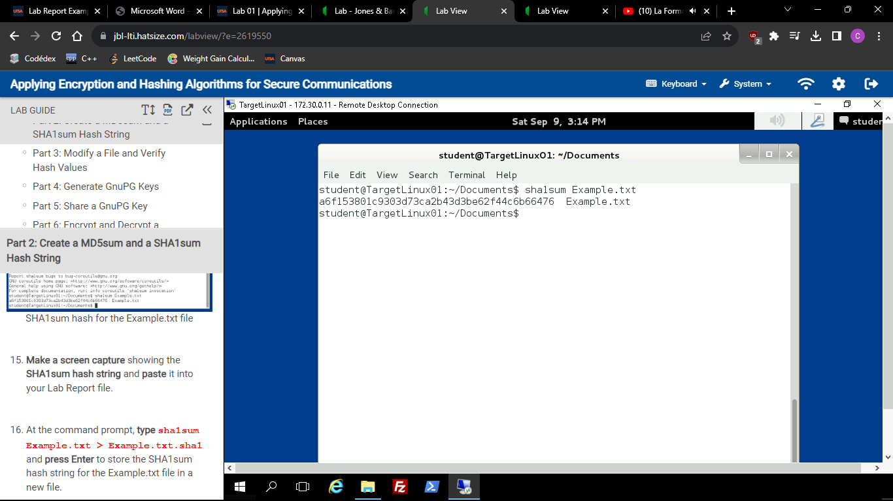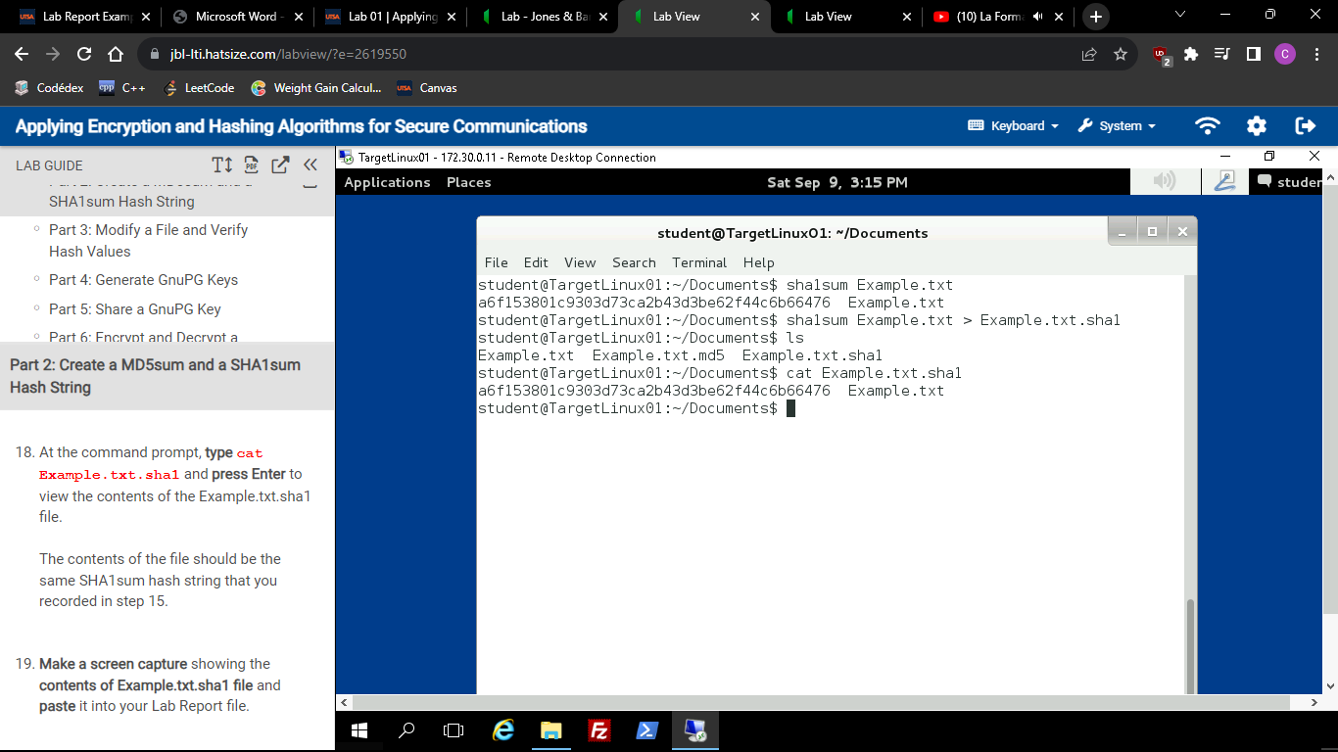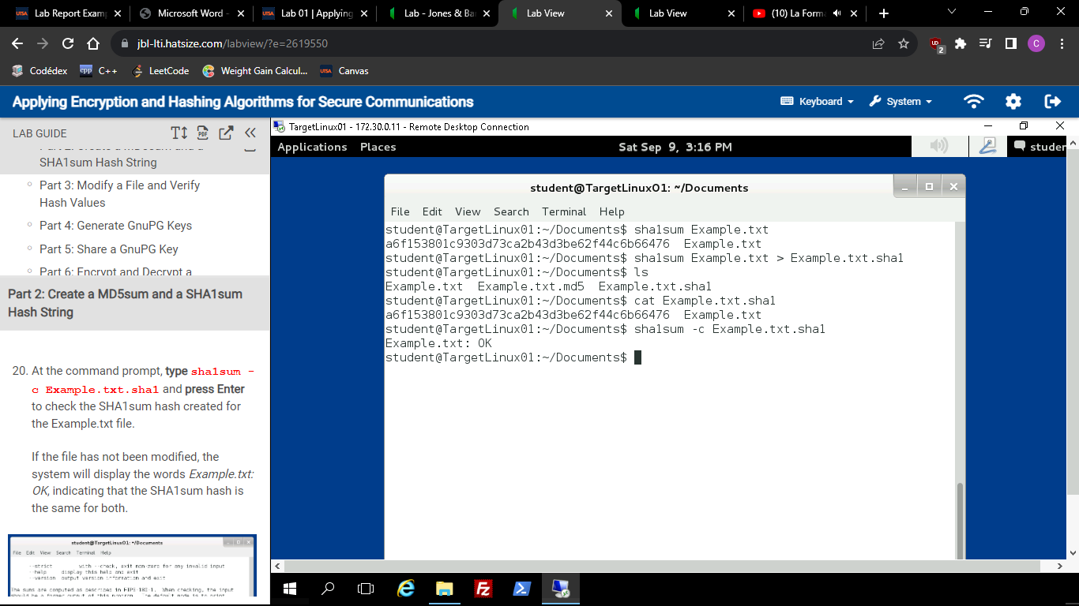

### Part 3: Modify a File and Verify Hash Values

Description: I added additional information into the Example.txt by echo-ing my name and then created files with the DM5 and SHA1 values in it. I compared them to the hash files that I got from the original file and they were in fact different.

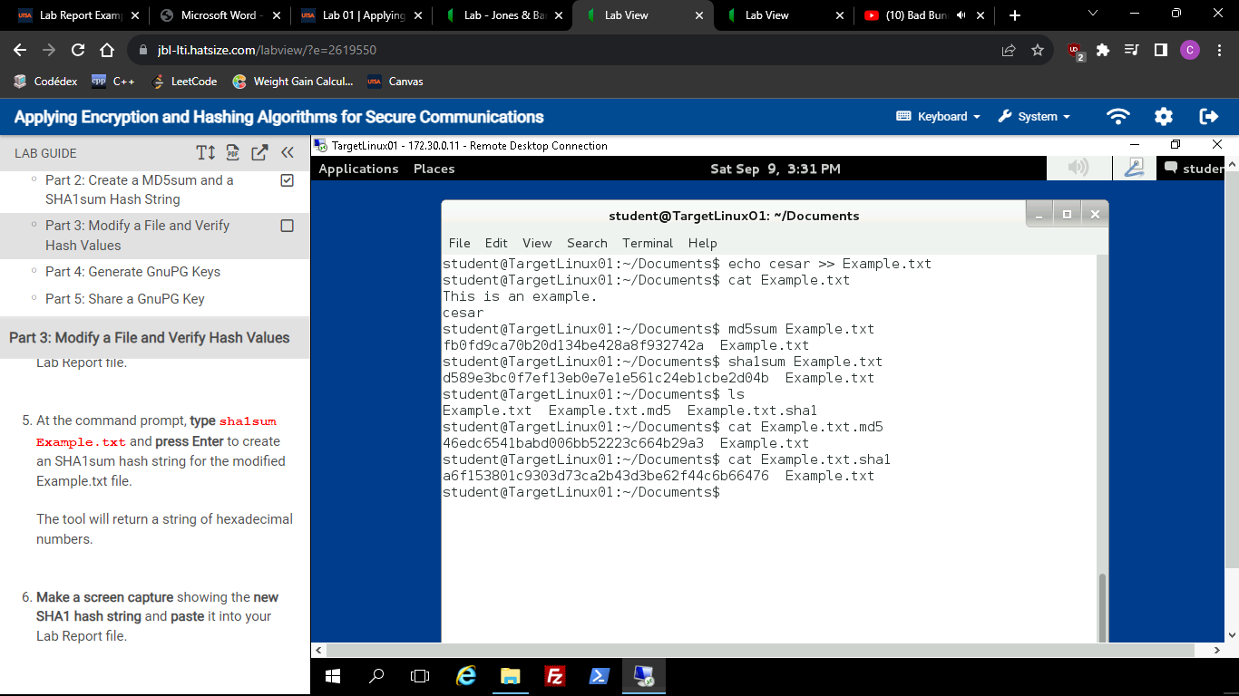



### Part 4: Generate GnuPG Keys

Description: The whole purpose of this part is to create keys for a proper communication.

I generated two GnuPG keys, one for the “student” user and one for the “instructor” user. I used command gpg –gen-key and followed the instructions to put the information in the according place. At the end a created a .pub file with command gpg –export -a > *user*.pub to store these different values for each of the users.

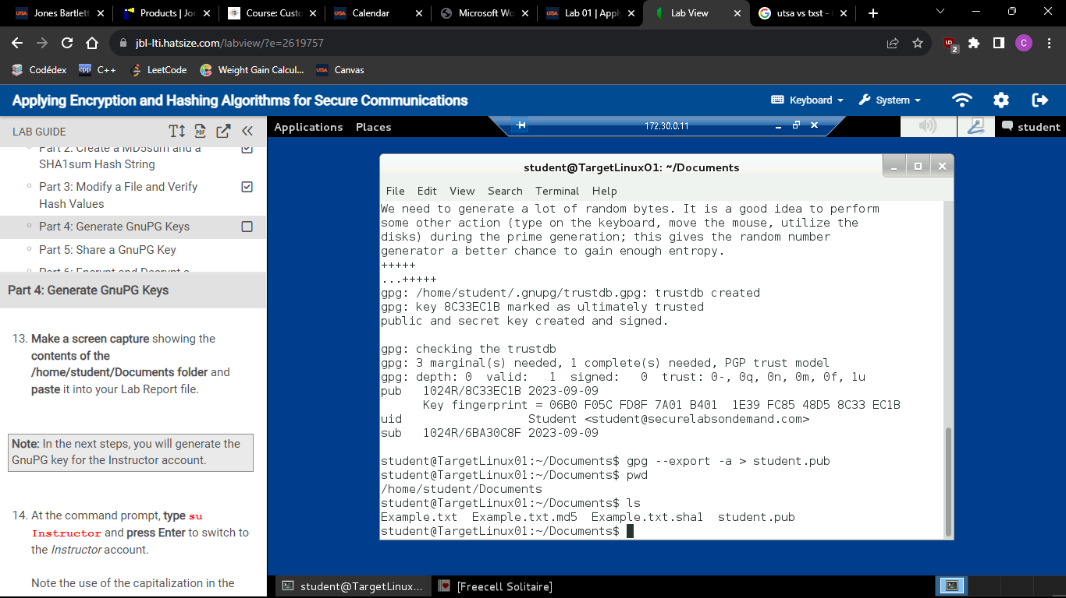



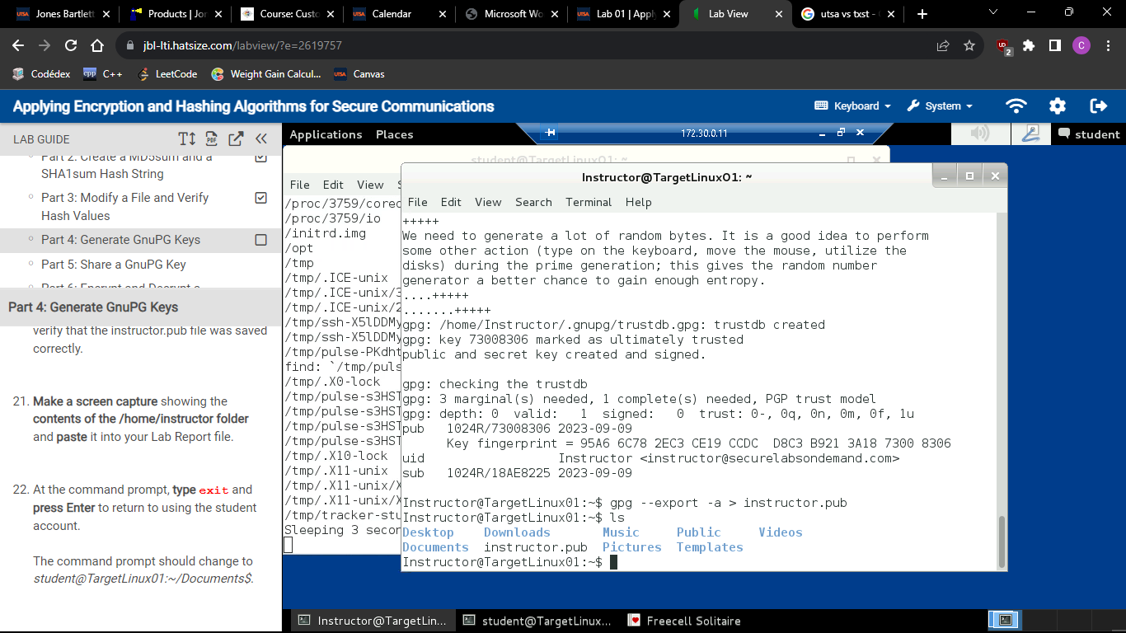



### Part 5: Share a GnuPG Key

Description: I copied the instructor.pub file that includes the key for the instructor and pasted into the student’s “Documents” folder. Then I imported the instructor.pub file to be able to share the key with the student, I used command gpg –import instructor.pub. Below is a screenshot that proves that both keys were shared.

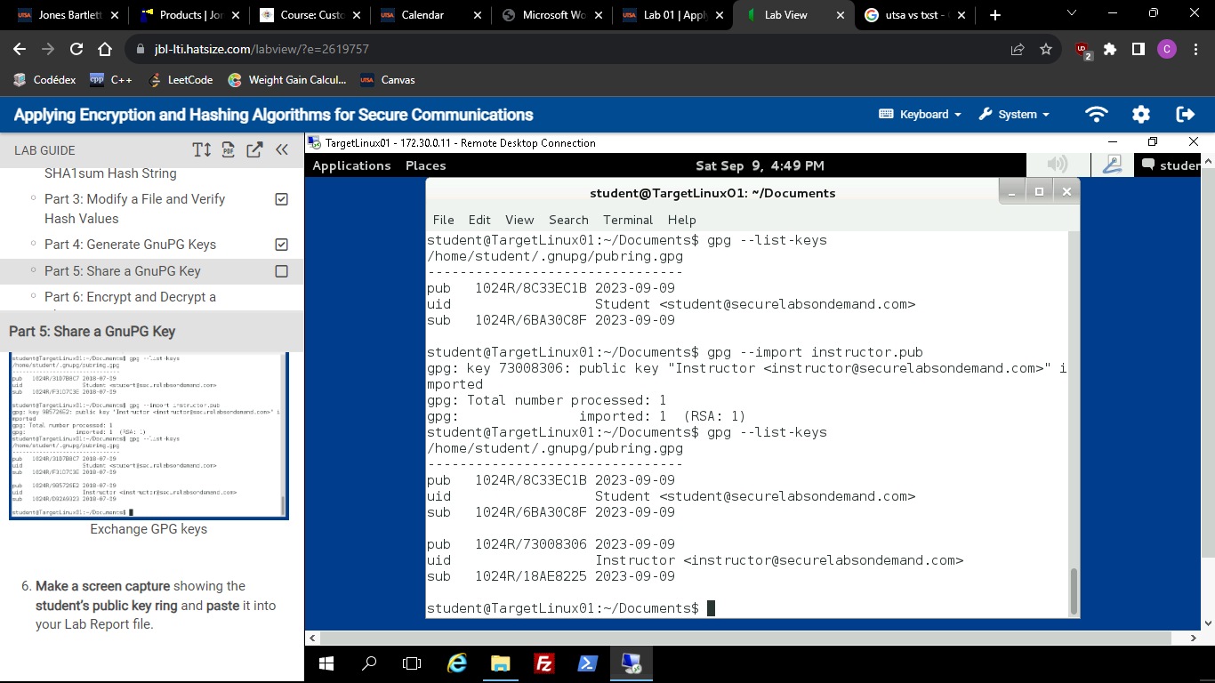



### Part 6: Encrypt and Decrypt a ClearText Message

Description: I echo-ed a text saying “this is a clear-text message from cesar” and saved it in a file called clear.txt. I cat-ed the file to confirm that it can display what I wrote on it. Then, while being the “student” user I encrypted the message using the gpg tool and the -e (to encrypt) command option. The recipient (receiver) was set to be the “Instructor” user. The cleartext.txt.gpg was created which it proved that the file was successfully created. I cat-ed the file and it was in fact encrypted because I only say strange values. Then I copied that same file into the Instructor home’s directory and I went into that same directory to change the privileges of the file because the student was the only one able to read it. I checked that the instructor has read privileges to the file by using command ls -la. I changed users to “Instructor” to decrypt the message. I used command gpg -d cleartext.txt.gpg and typed the “today is a nice day” passphrase to I used as a key before. The terminal displayed the contents of the decrypted file and it was in fact the same message I put at the very beginning.

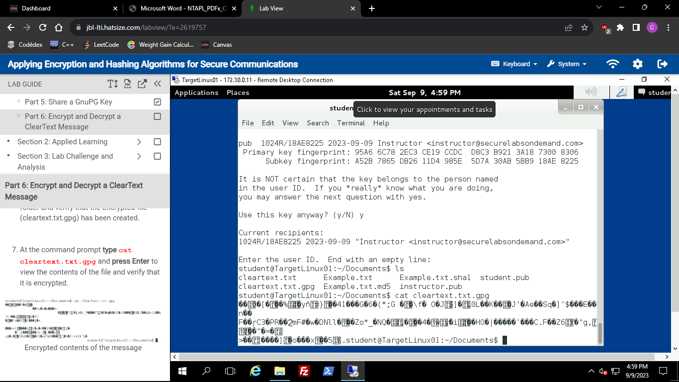



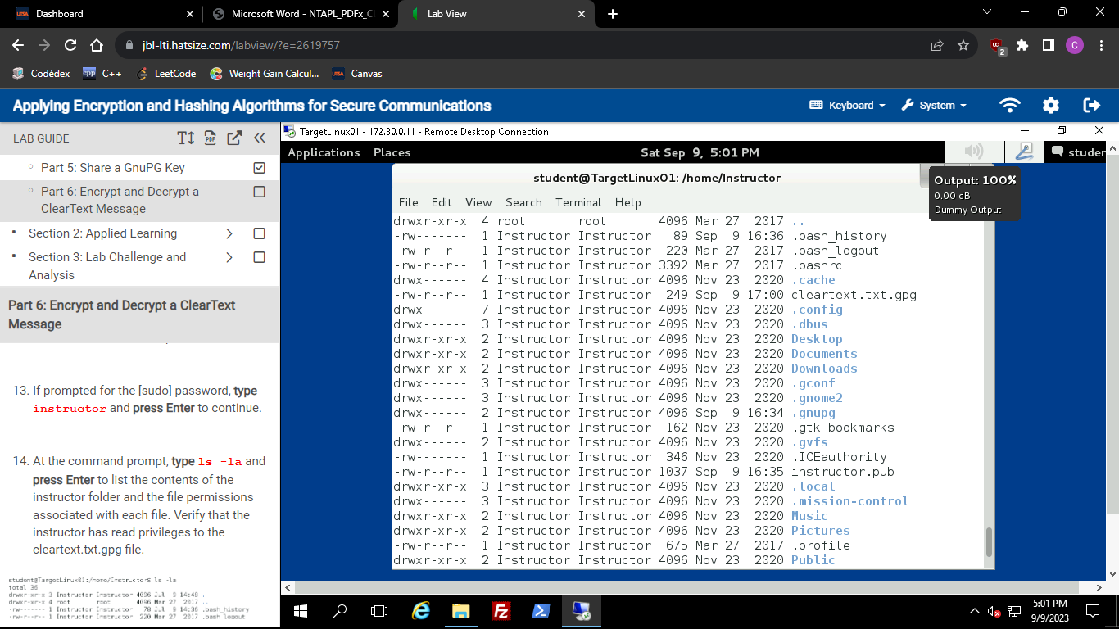



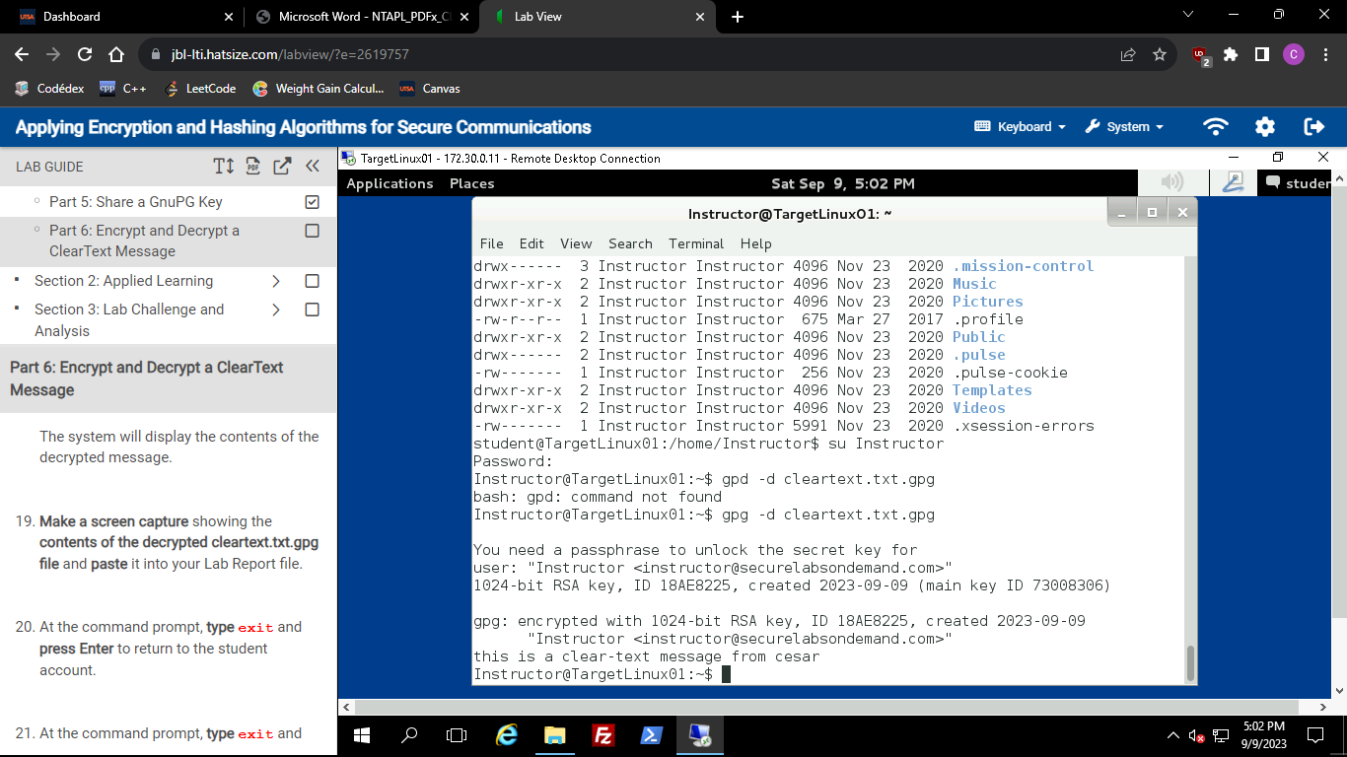



# Section 2: Applied Learning

### Part 1: Create a Text File on Linux

Description: I opened the TargetLinux01_CMD in my connections folder by double-clicking it. I made sure I was the right user by using command whoami. I used the vi editor to create a new file containing “This file is from cesar”, saved it and exited the editor. I successfully created a file and cat-ed its content to verify.

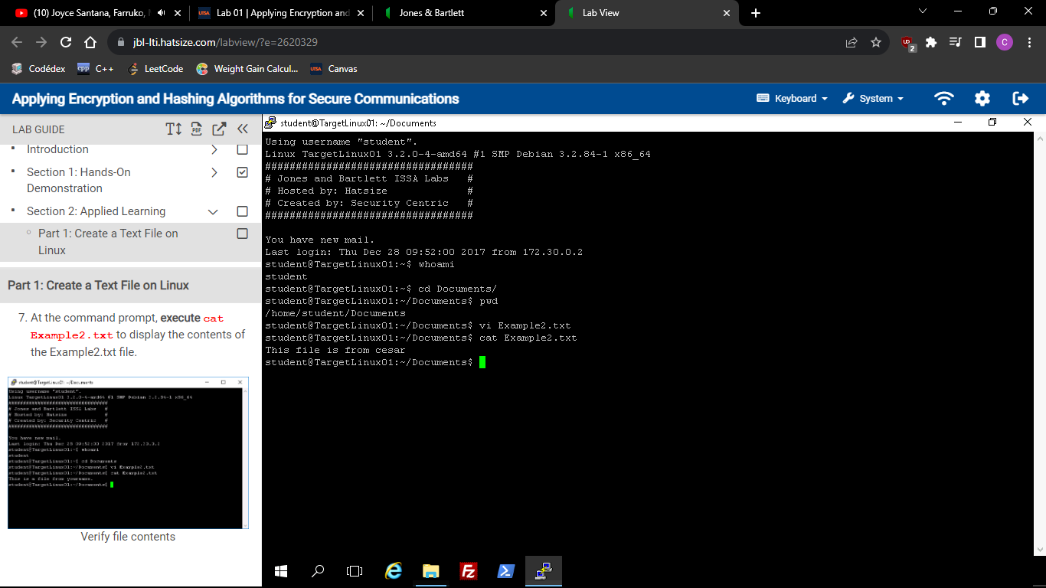

### Part 2: Create a MD5sum and a SHA1 Hash String

Description: I created md5 and sha256 hash values for the Example2.txt that I’ve created previously. I used the command md5sum Example2.txt > Example2.txt.md5, and sha256sum Example2.txt > Example2.txt.sha256. I made sure that the files were created by listing the files in the directory using command ls. I checked for its appropriate hash value using the -c command option, the actual command was md5sum -c Example2.txt.md5 and sha256sum -c Example2.txt.md5 respectively. Both actions displayed an “OK” in the terminal.

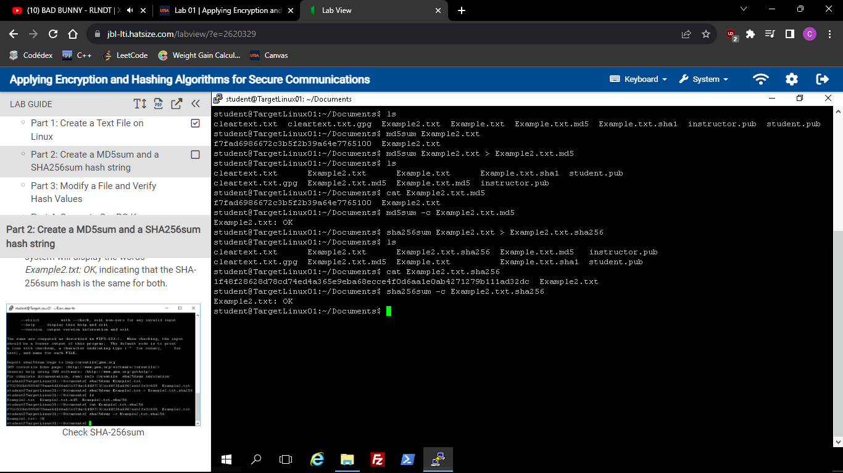



### Part 3: Modify a File and Verify Hash Values

Description: In this part, I echo-ed “This example is testing hash values.” To the Example2.txt that was already created. Essentially, it added that extra sentence into it so that the hash values can be different. After that I did the same steps I did in part 2 where I would create a new respective hash value and then overwrite the corresponding files. I compared the two different hash values from the original file and the modified one and they were in fact different.

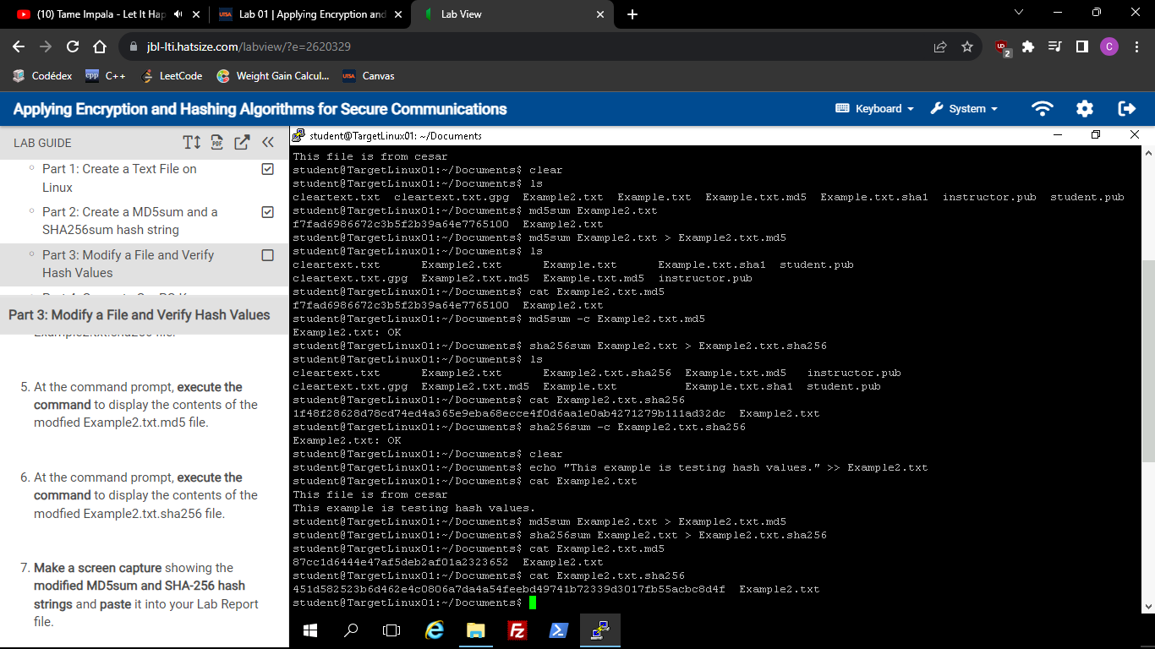



### Part 4: Generate GnuPG Keys

Description: I made sure I was using the correct user by using command whoami. I then generated a new GnuPG key named Student2 and used the same steps I did for creating a key for Student in Section 1. The passphrase was given to me and it was “encryption key” which I used in this situation. I did some background work to “keep the machine busy” and create some entropy by running a script with command ./entropy_loop.sh. The entropy was made and was able to continue with the creation of a key for the student user. I saved the key to a new file called student2.pub. I listed the keys and it was there. I did the same process using the instructor user. Created a key using command gpg –gen-key and followed the same previous steps. I listed the keys for the instructor user and its key was there in a file called instructor2.pub.

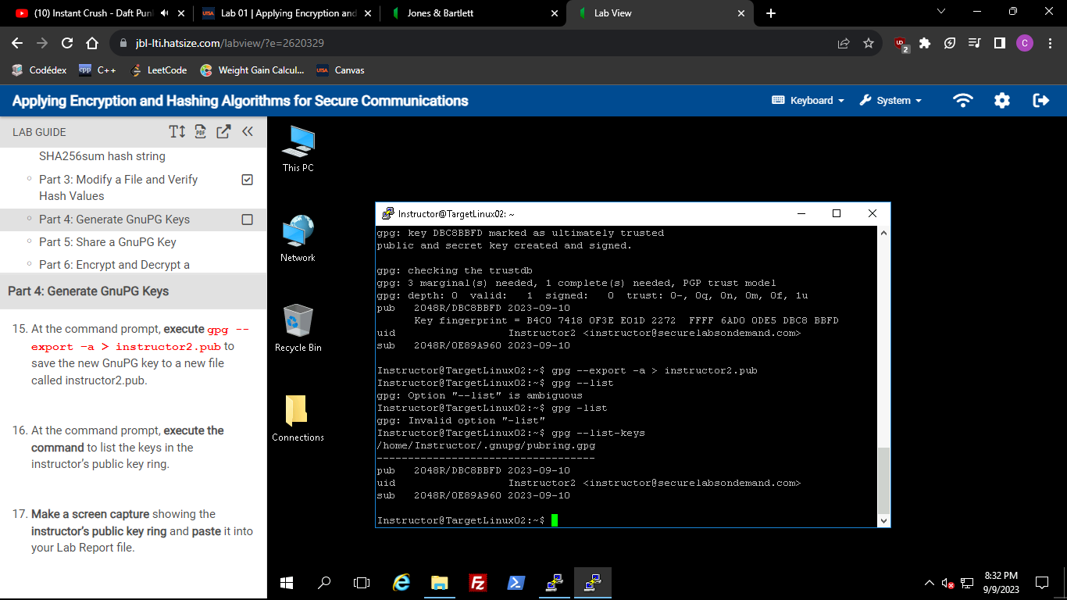



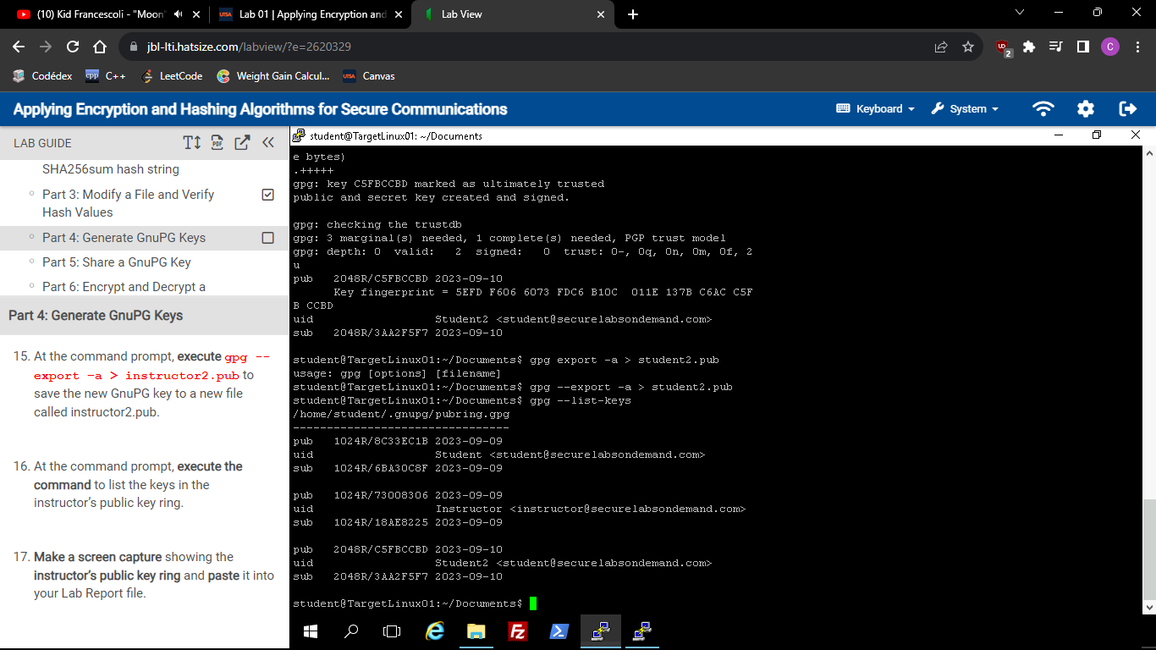



### Part 5: Share a GnuPG Key

Description: I opened the KeyTransfer 12 (Instructor side) shortcut from the connections folder. I copied the key generated and stored in instructor2.pub file to the /Users/Administrators/Documents directory. Then, I opened the KeyTransfer11 (Student side) shortcut from the connections folder and copied the instructor2.pub file to TargetLinux01 by just dragging the file to the right side. I right-clicked that same file to change the permissions by choosing student[1000] as the owner. Went back to the student terminal (TargetLinux01 PuTTY) and listed the contents of the Documents folder to check if the instructor2.pub was there and it was. I imported the key by using gpg –import instructor2.pub. Then I displayed the list of keys for the student side.

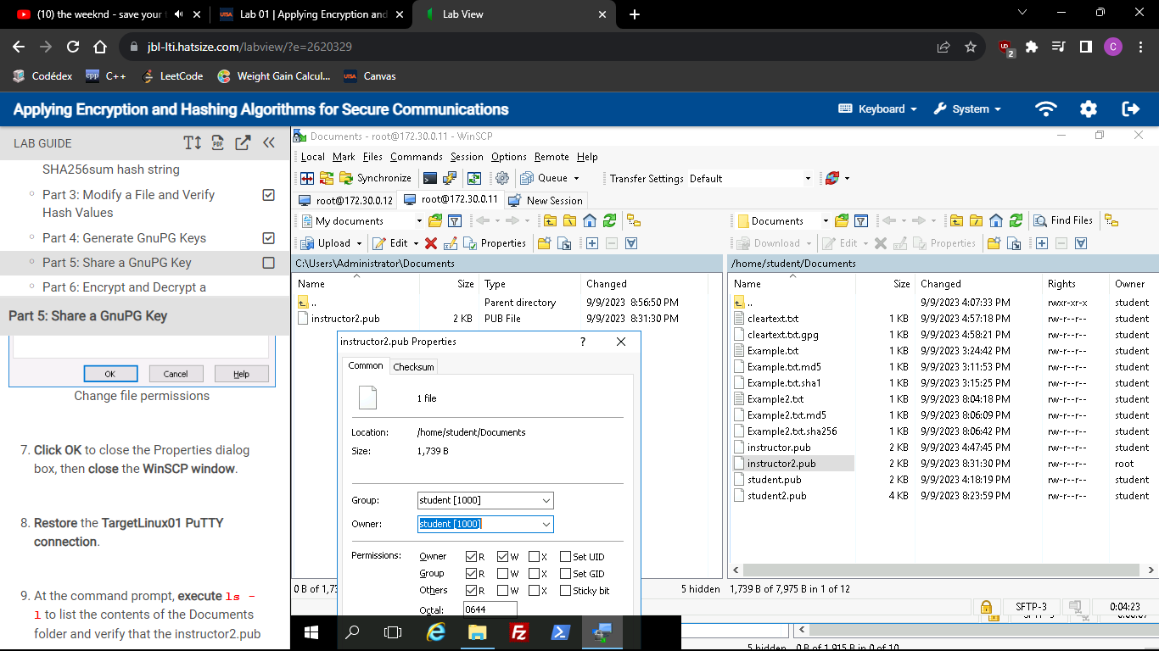



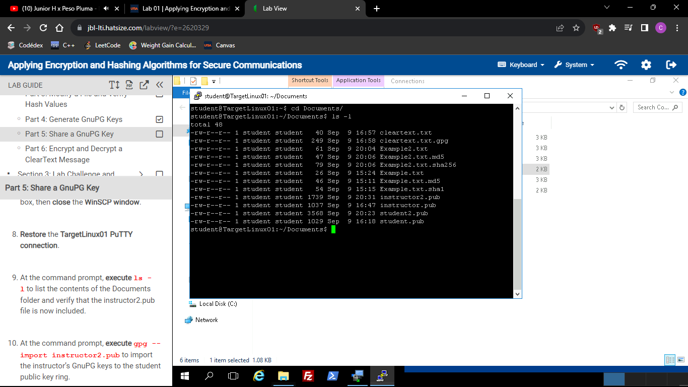



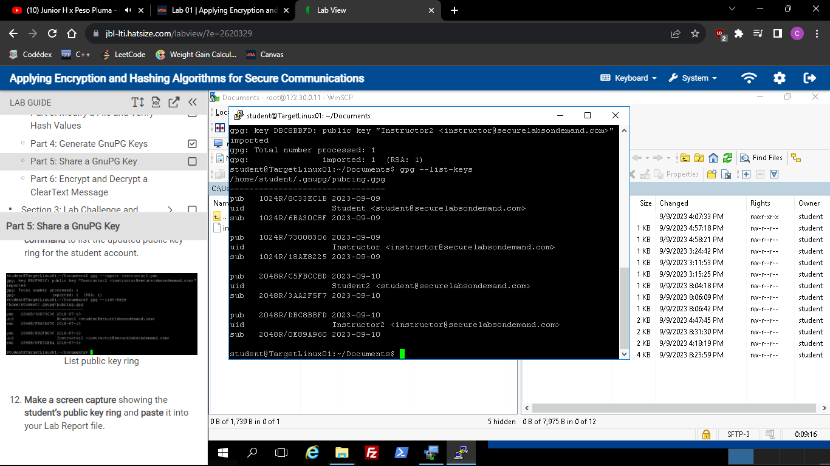



### Part 6: Encrypt and Decrypt a ClearText Message

Description: I echo-ed “This clear-text message is from cesar” and put it in a file called cleartext2.txt. I used command gpg -e cleartext2.txt to encrypt the message and set the recipient to Instructor2. I made sure the new encrypted file was there by using the ls command. The file was successfully encrypted because I tried cat-ing the content and it didn’t work. I copied the encrypted file from student and pasted into the instructor’s Documents folder. I changed the permissions of the file so that the owner could be the Instructor. Then, I went back to the Instructor terminal and decrypted the file using command gpg -d cleartext2.txt.gpg and typed the passphrase “encryption key”. The file was successfully decrypted. A screenshot is shown to prove that the message was decrypted correctly.

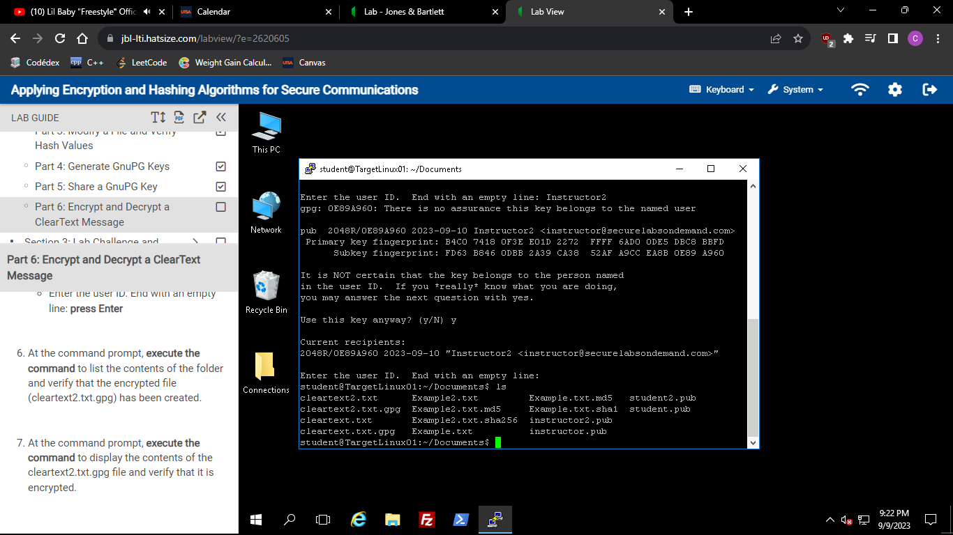



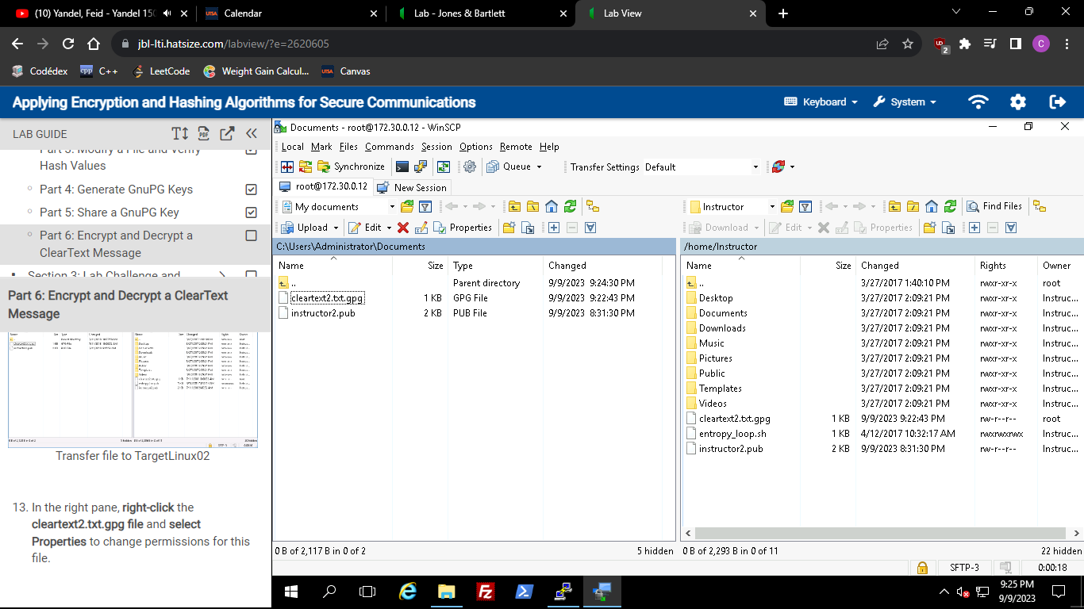



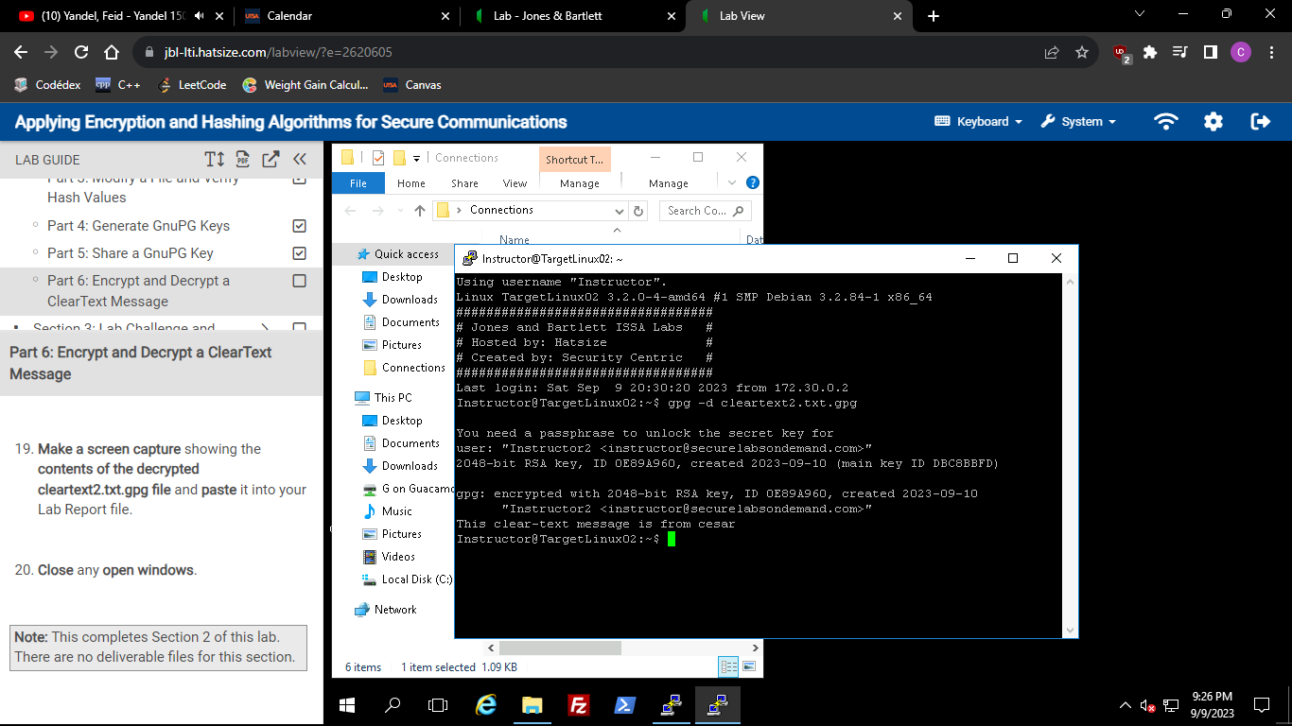



# Section 3: Lab Challenge and Analysis

### Part 1: Analysis and Discussion

Instructions: Describe the differences between RSA and ECDSA encryption algorithms, and name a well-known product that uses each type of encryption.

An RSA encryption is an algorithm that consist of two different keys a public key and a private key. Either key (public/private) can encrypt a message, however, the opposite key is the only one able to decrypt a message between a communication. For instance, if computer A wants to send a message to computer B, it can use computer B’s public key to encrypt the message and have the private key of computer B to decrypt the message.

An ECDSA encryption is an algorithm that relies on cyclic groups of elliptic curves and its complexity, which makes it a good option whenever you want to deal with encryption and cryptography. It is also consisted of two keys; a public key and a private key. It’s some sort of combination of the RSA algorithm but it also requires more math. (ECDSA: Elliptic Curve Signatures)

Some products that use RSA encryption algorithm are VPNs and SSL certificates. One product that uses ECDSA is Bitcoin.

### Part 2: Tools and Commands

1. I created a new file called Send.txt and added the following text: “My name is cesar”. I used command echo “My name is cesar” > Send.txt.

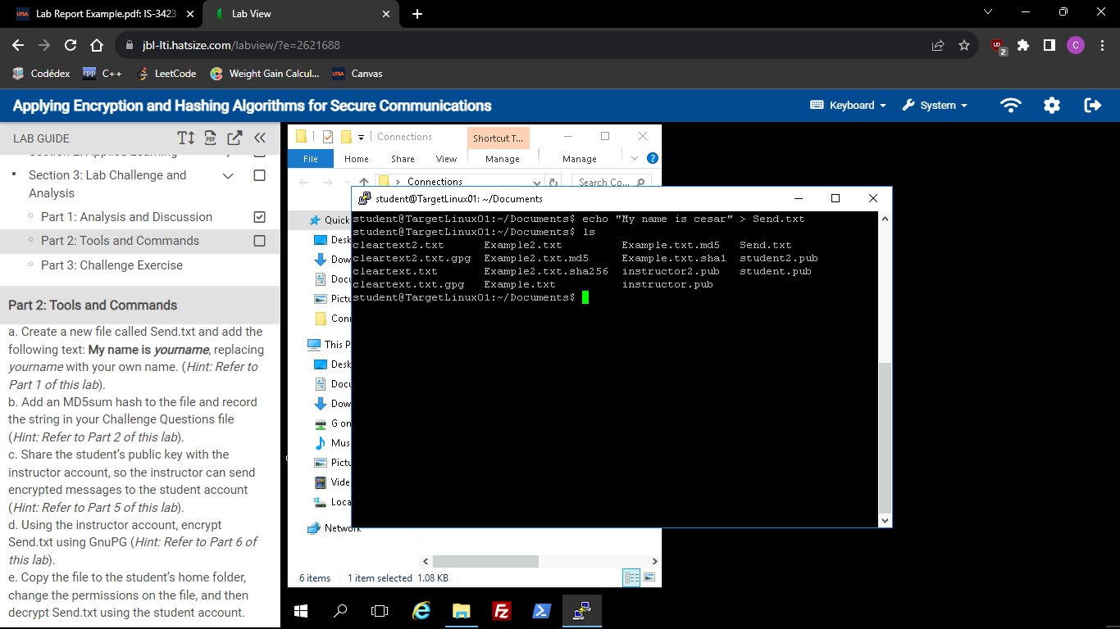

1. I added an MD5sum hash to the file and saved it as a new file called Send.txt.md5 which contained the md5 hash value in it.

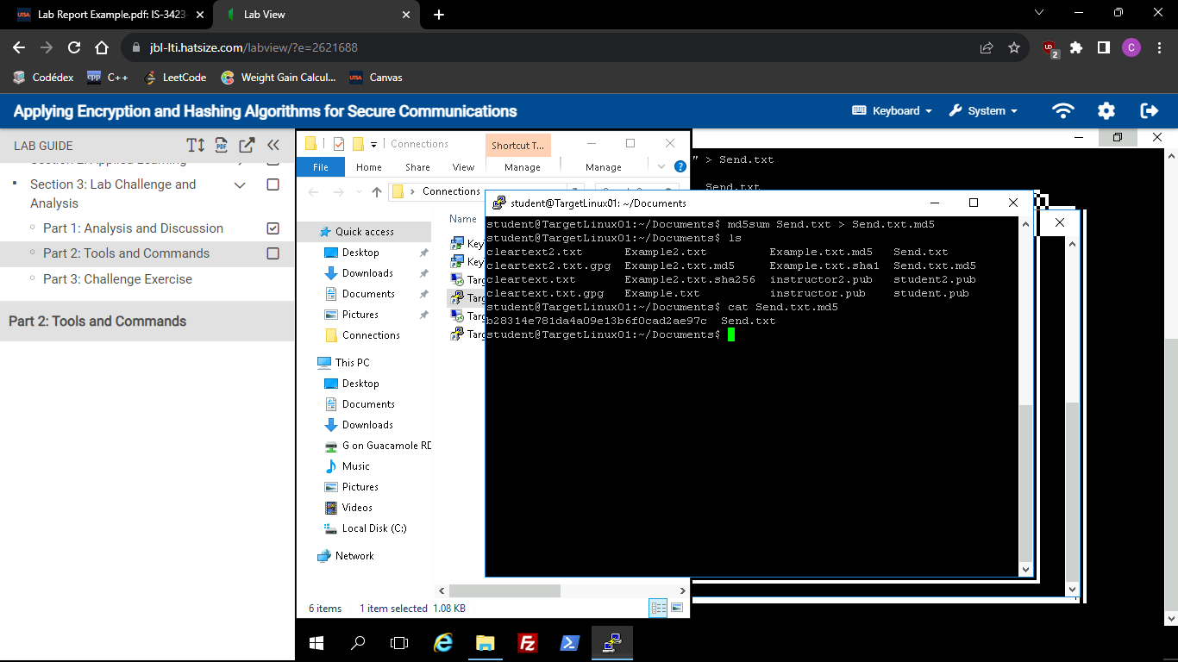

1. I shared the student’s public key with the instructor’s account, so the instructor can send encrypted messages to the student account.

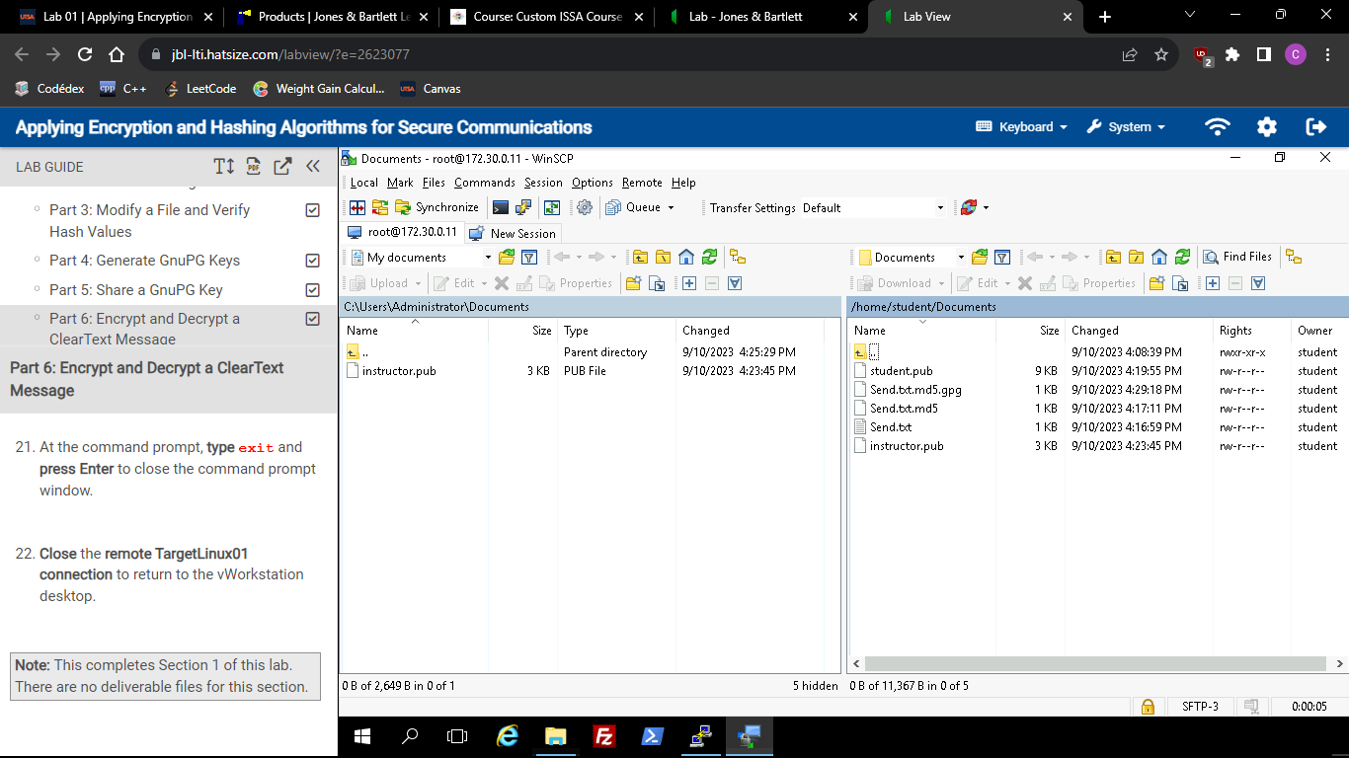

1. I switched to instructor account and encrypted the text file using GnuPG.

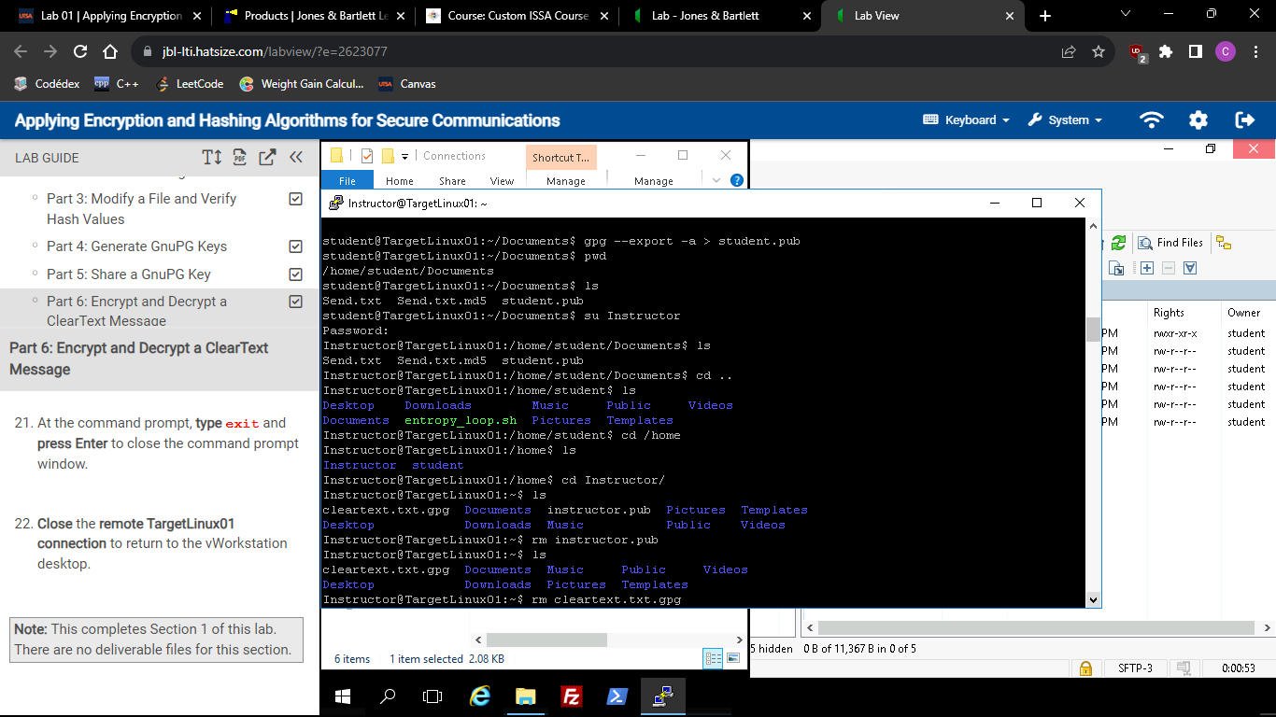

1. I copied the file to the student’s home folder, changed the permissions, and then decrypted the text file using the student account. In this part I encrypted the MD5 value of the Send.txt instead of the actual plaintext.

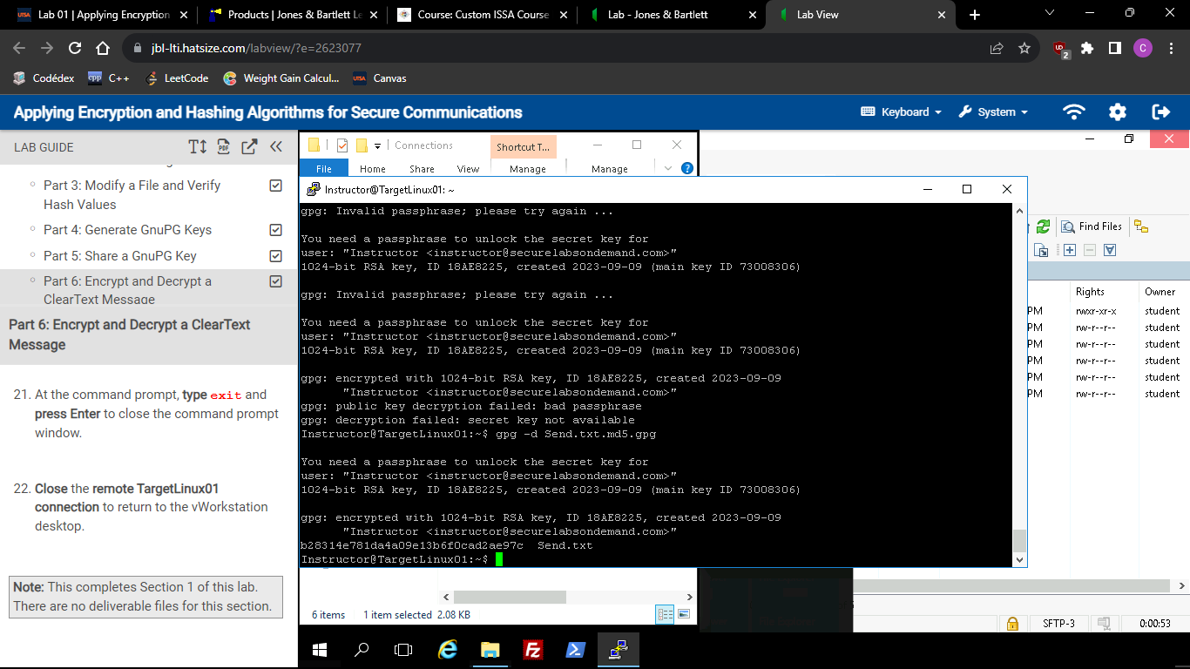

### Part 3: Challenge Exercise

Description: In this part I used the AES256 encryption algorithm by using command gpg –symmetric –cipher-algo AES256 cesar.txt. It is important to mention that AES256 requires only one key, which is why its symmetric. I then went to the student user to decrypt the message by using gpg -d cesar.txt.gpg and it worked successfully.

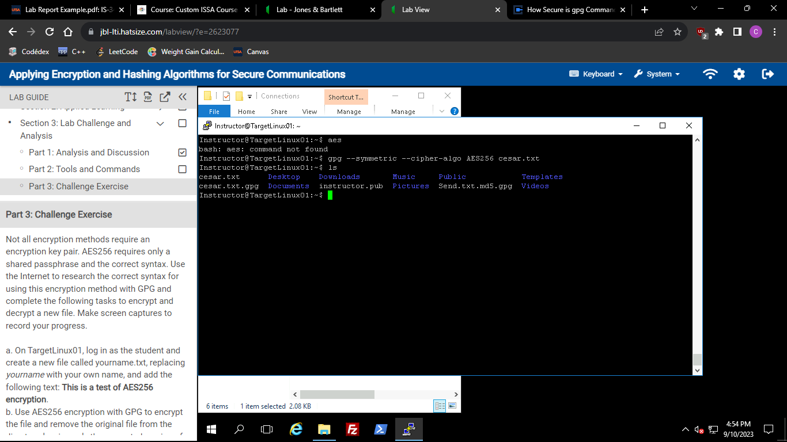

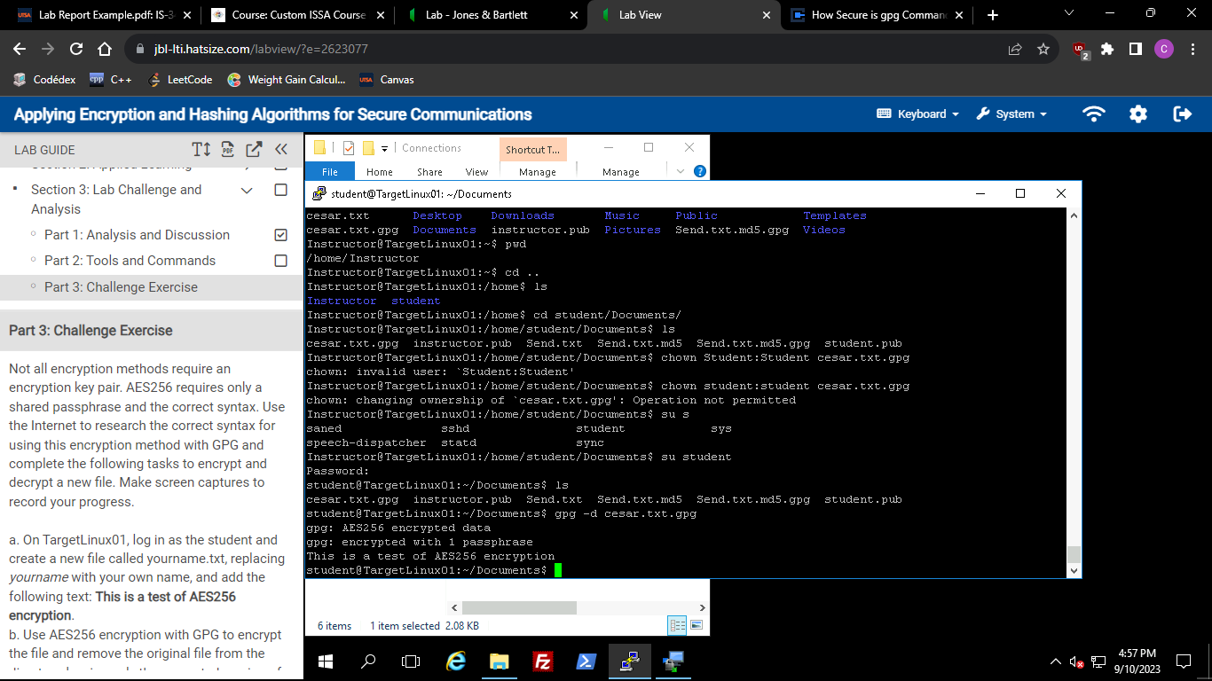

# Works Cited

“ECDSA: Elliptic Curve Signatures.” *ECDSA: Elliptic Curve Signatures - Practical Cryptography for Developers*, cryptobook.nakov.com/digital-signatures/ecdsa-sign-verify-messages. Accessed 10 Sept. 2023.